Rajashekhar Reddy-02-Aug-2024-----**Challenge task on Recover the pem key**

1. **Launch one ec2 instance with t2.micro and pem key with name "Aug-02.pem"**

**\*** Open the AWS Console

* went to the ec2 Instance, then click on launch instance to creating one new instance

* selected AMI as Amzon linux with t2.micro type

* then I created new pem key named as “Aug-02”

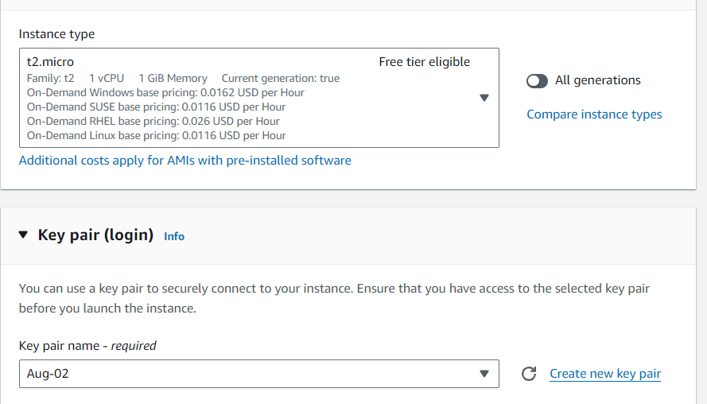

* Created new Instance

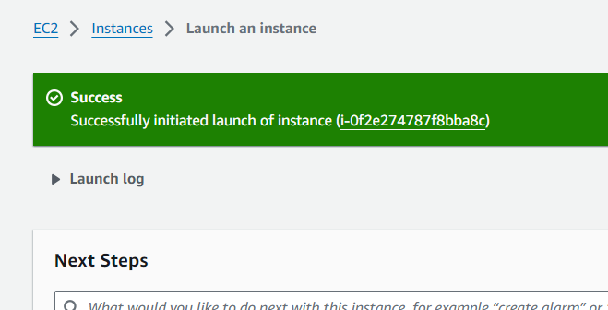

1. **Login and go to /opt directory and create one file with name "Techie_Horizon" and content "Old server".**

**\*** Logged into the created server which has generated with “Aug-02.pem”

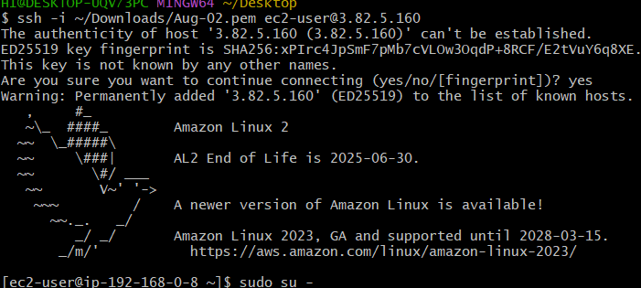

* Went into the “/opt/” Folder

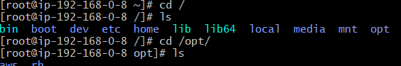

* Created a file named as “Tehie_Horizon”

* Added content “old server” in this file.

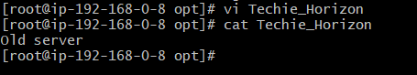

1. **Delete the pem key from your machine.**

**\*** Deleted the pem key(Aug-02.pem) from local machine

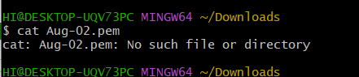

**4) I want you to recover the pem key and the name of new pem key should be "Challenge.pem"**

Detach the volume of 1st instance

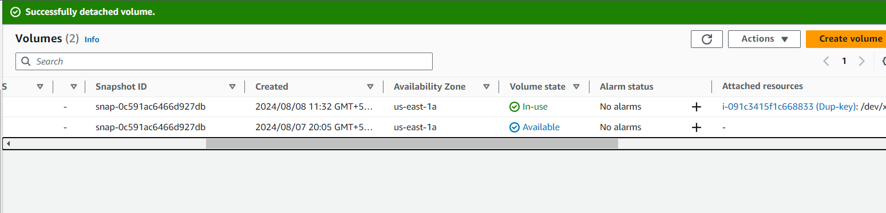

* Connected to 2nd instance

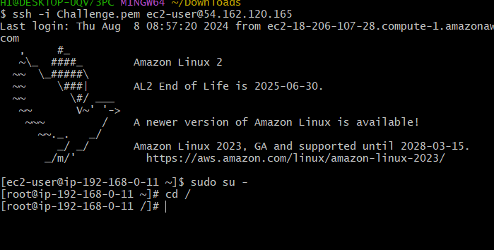

*Stop the instance of 2nd instance

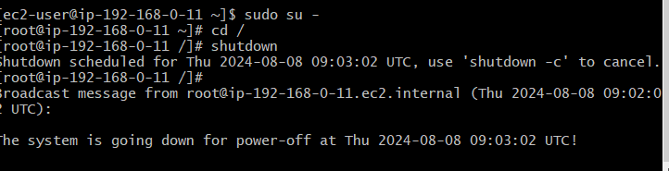

* Attaching the 1st volume

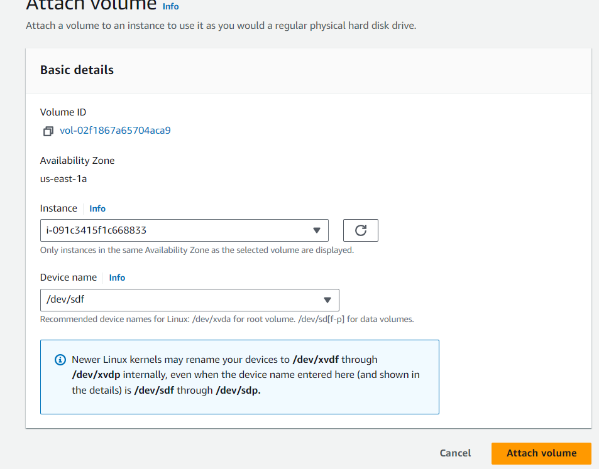

* Attached the 1st voume into 2nd volume of intance.

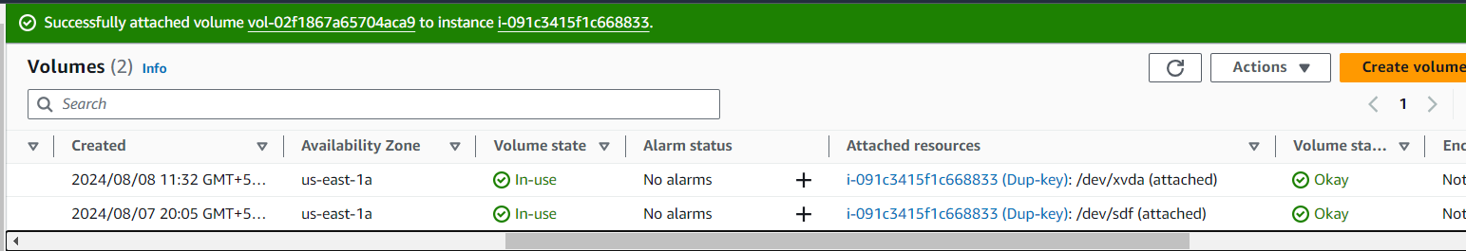

* First connected to 2nd Instance then check the list of volumes are available or not by using “lsblk”

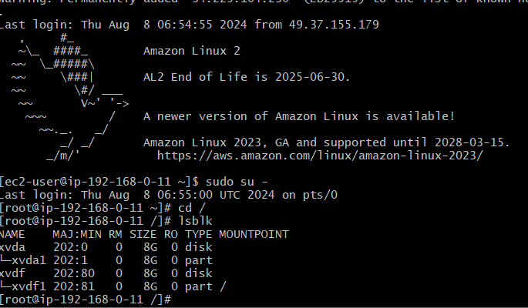

*Wheather I checked the mount files are avilale I this machine or not “ ls /mnt”

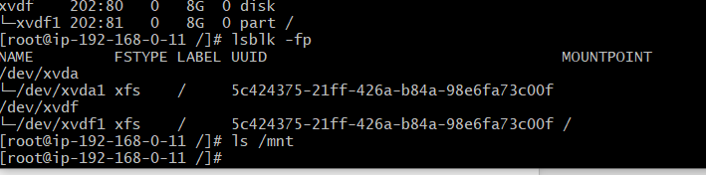

* If not available mounted the volume of files of 1st instances by using “ mount -o rw,nouuid /dev/xvdf1 /mnt”

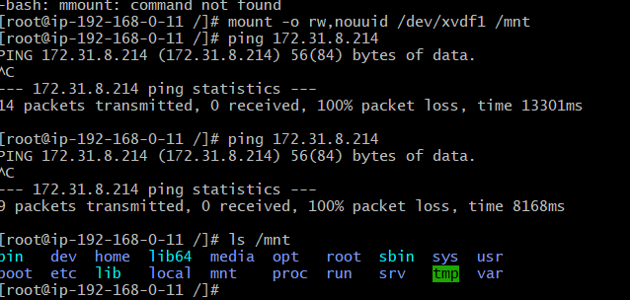

* By using “cat /root/.ssh/authorized_keys >> /mnt/root/.ssh/authorized_keys “ Command to mount the key into another mount folder

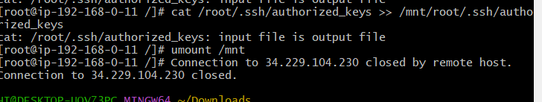

* Connected to original instance using 2nd instance pem key(Challenge.pem”

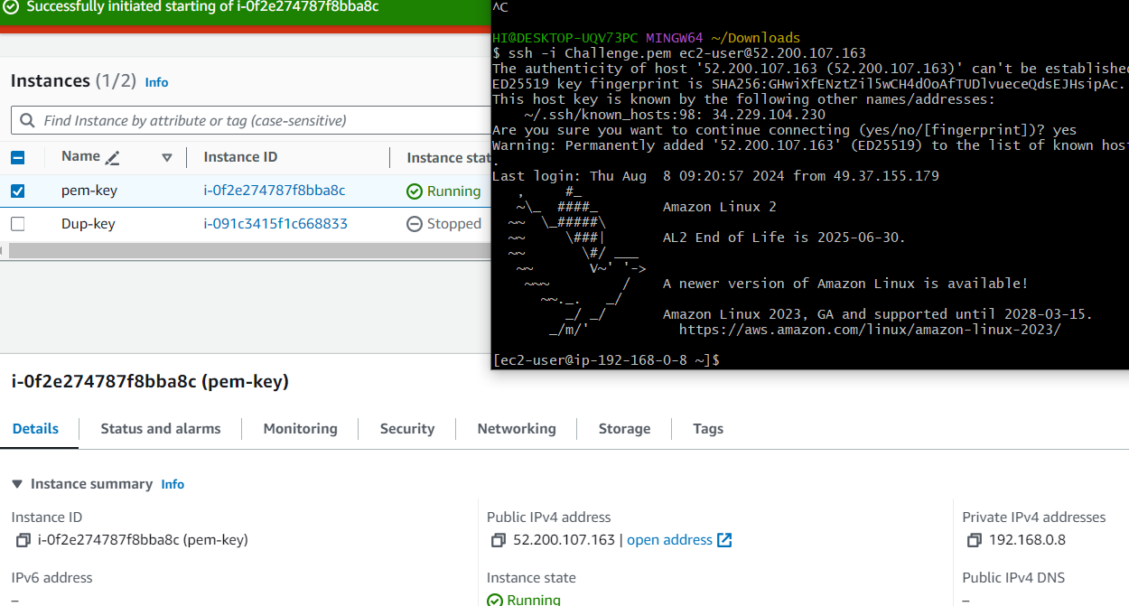

**5) Validation will be based on the file created in old instance.**

